* 

This is called smiths determinant.

In general if aij = f(gcd(i, j)) then deteminant is 

* 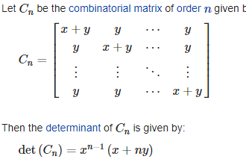

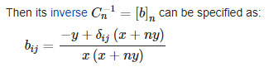where delta(i, j) = [i == j]

* 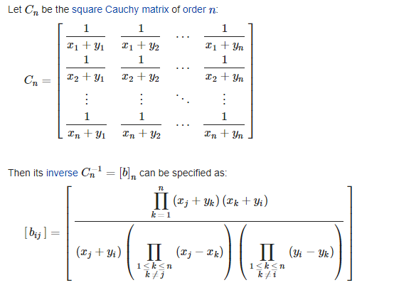

Determinant: 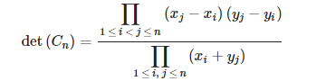

* 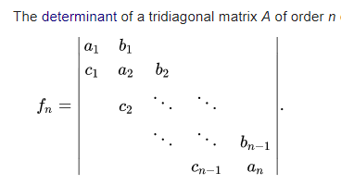 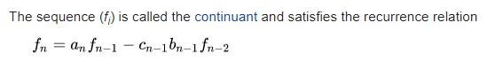

Where f[1] = |a[1]|, f[0] = 1, f[-1]=0

* 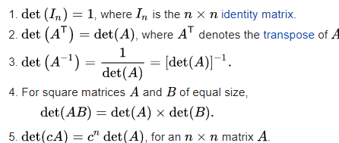
* 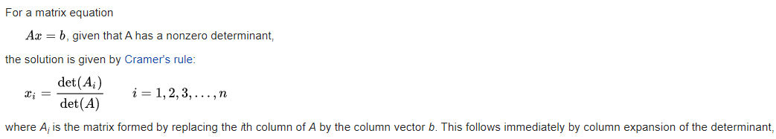
* the determinant of a matrix (with real or complex entries, say) is zero if and only if the column vectors (or the row vectors) of the matrix are linearly dependent
* 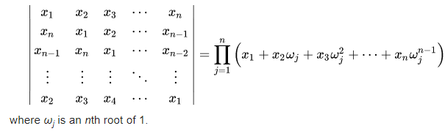
* Number of Permutations of length n such that adjacent elements has difference > 1:

If n = 0 or 1 then a(n) = 1; if n = 2 or 3 then a(n) = 0; otherwise a(n) = (n+1)\*a(n-1) - (n-2)\*a(n-2) - (n-5)\*a(n-3) + (n-3)\*a(n-4).

It is also solution ways to arrange n non-attacking kings on an n X n board, with 1 in each row and column.

* Suppose you have a group of married couples (plus perhaps one other person).

You wish to organize a gift exchange so that:

- each person gives and receives one gift.

-no one gives himself a gift.

- no one gives his/her spouse a gift.

a(n) = (n-1)\*a(n-1) + 2\*(n-d)\*a(n-e), where (d, e) = (2, 4) if n even, (1, 2) if n odd.

It is also solution of Permanent of the binary matrix with an entry equal to 0 iff the entry is on the main diagonal or the main antidiagonal

Also solution of Number of permuations p of (1, 2, 3..,n) such that i != p[i] && n-i + 1!= p[i];

* Solve x for x^P = A mod Q, x has solution iff A^((Q-1) / P) = 1 mod Q